1. Home page is created with header and footer with the crxde

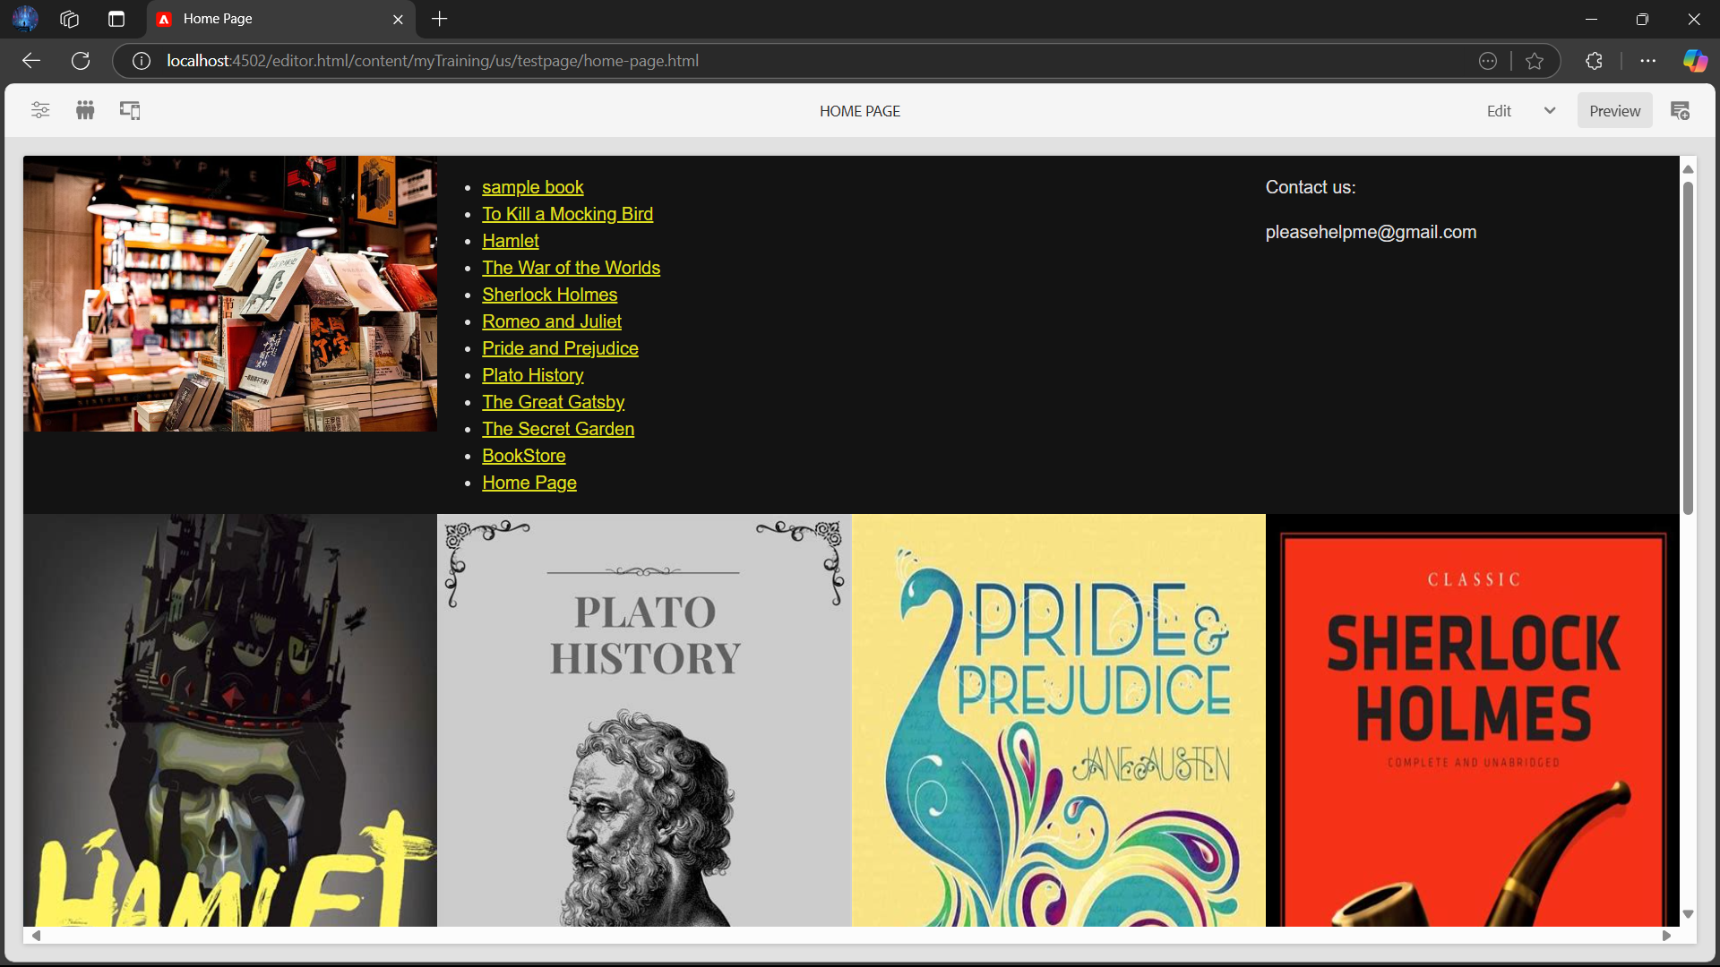

1. Custom page property is added to the book component which allows to add the script manually. It is identified by the name addScript.

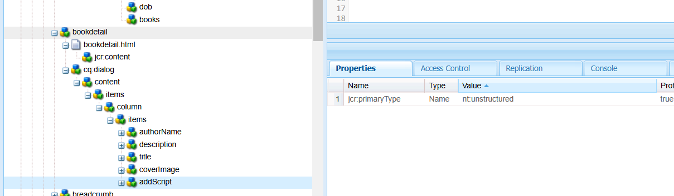

1. The author component is updated. A new field of books is added to author component.

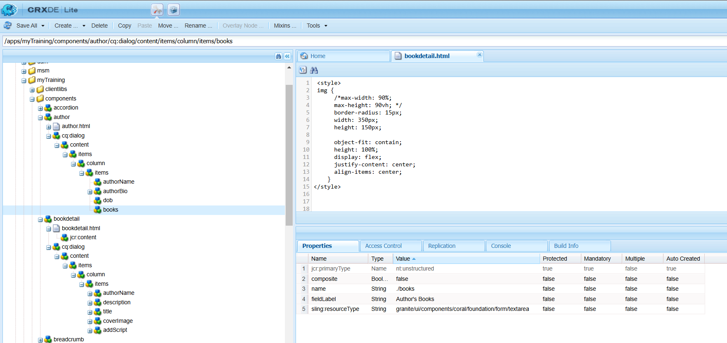

1. About book template is created which holds the header and footer where the details of the books are stored.

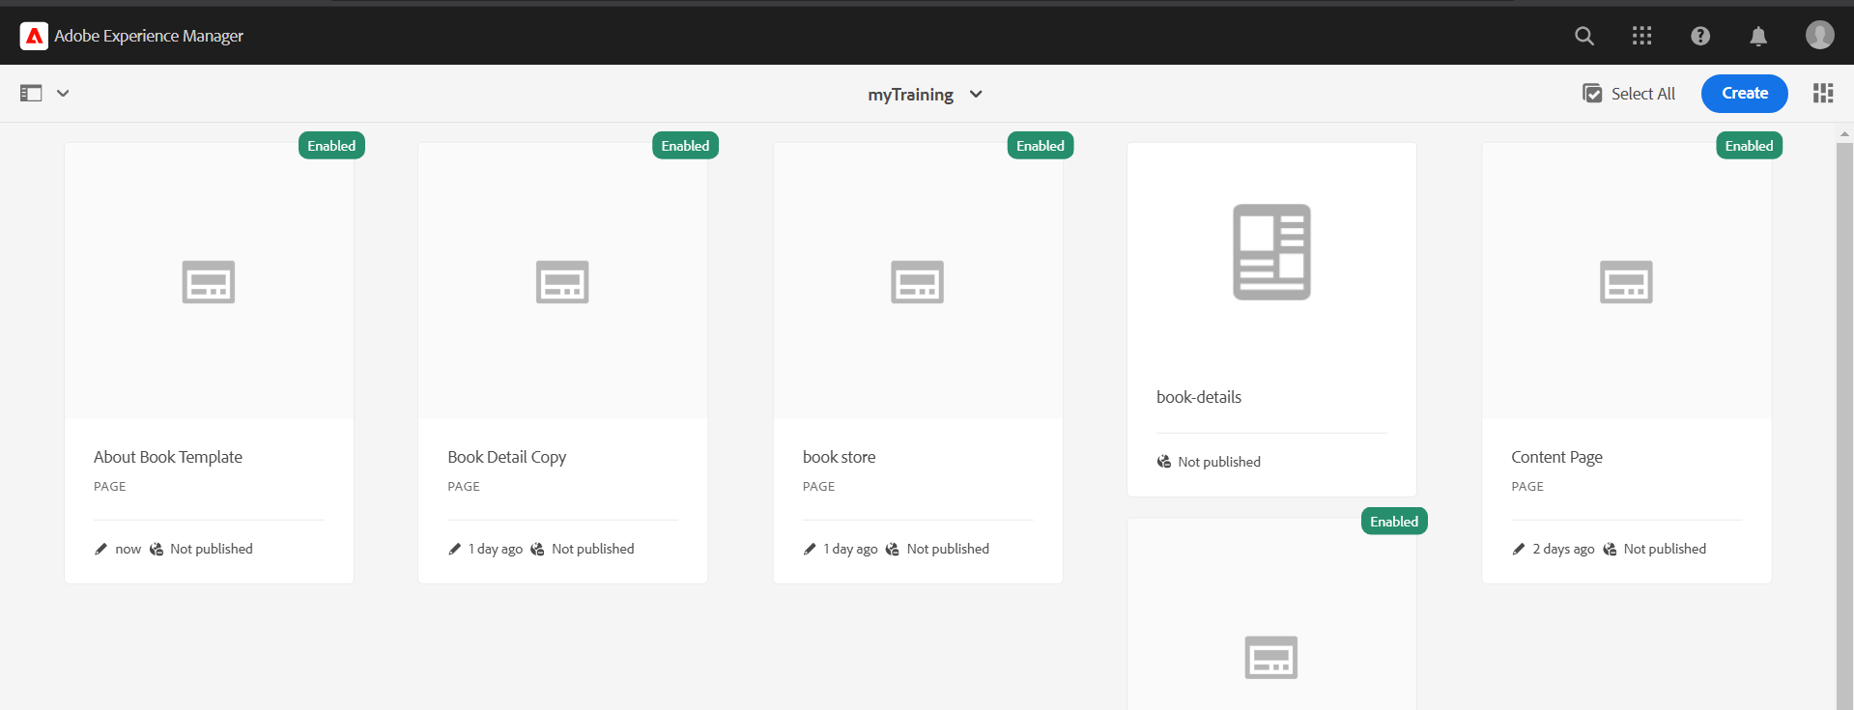

1. It gives the description of the author and their details

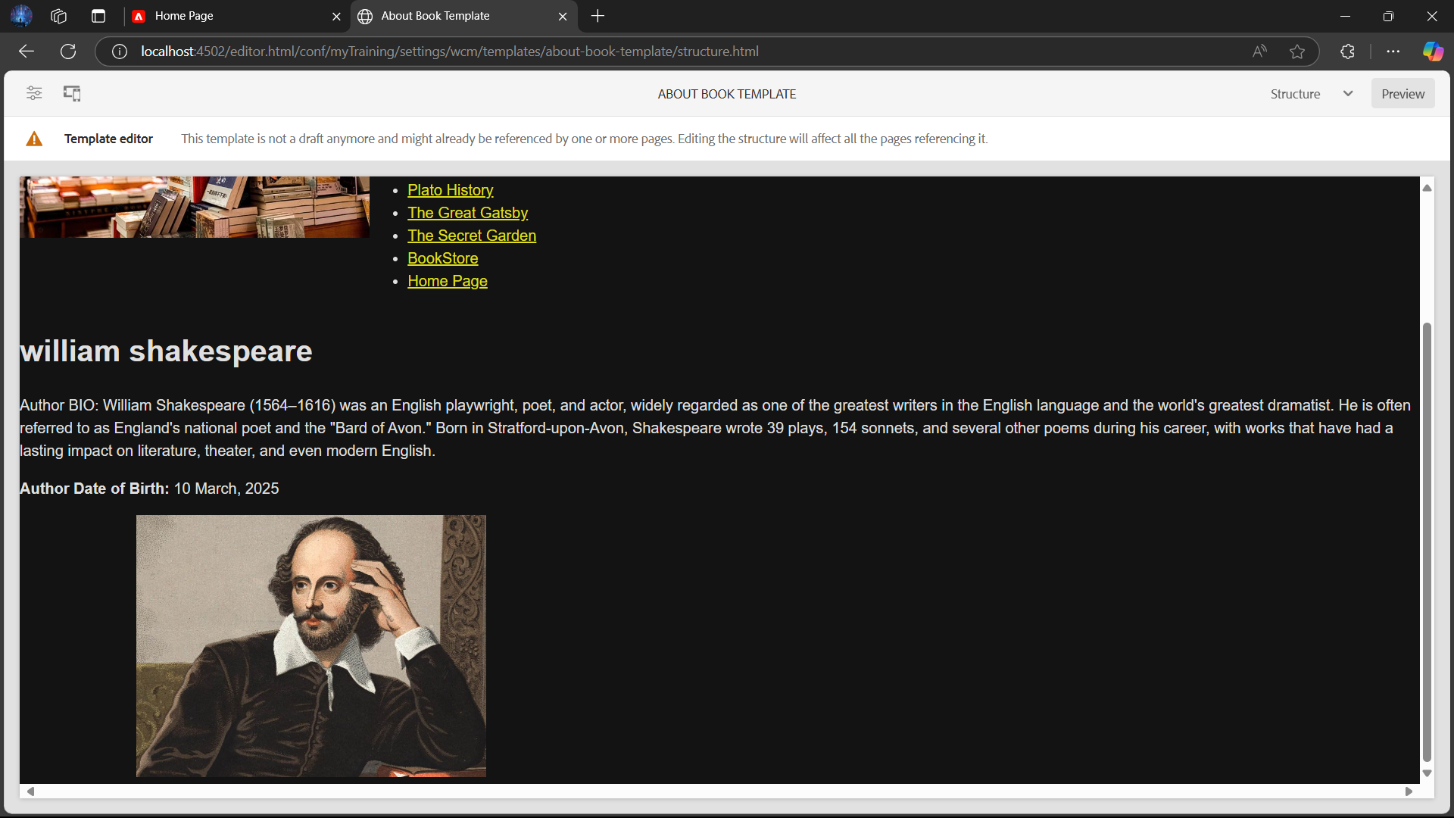

The details of the author is opened in dialog for author to fill up.

